**DATA SCIENCE AND MACHINE LEARNING**

**LAB CYCLE-3**

**Submitted By,**

**Subin Sabu**

**20mca051**

**3rd MCA**

**1. Sarah bought a new car in 2001 for $24,000. The dollar value of her car changed each year as shown in**

**the table below.**

**Value of Sarah&#39;s Car**

**Year Value**

**2001 $24,000**

**2002 $22,500**

**2003 $19,700**

**2004 $17,500**

**2005 $14,500**

**2006 $10,000**

**2007 $ 5,800**

**Represent the following information using a line graph with following style properties**

**• X- axis - Year**

**Y –axis - Car Value**

**• title –Value Depreciation (left Aligned)**

**• Line Style dashdot and Line-color should be red**

**• point using * symbol with green color and size 20**

**Code**

**import matplotlib.pyplot as plt**

**import numpy as np**

**xpoints = np.array([2001, 2002,2003,2004,2005,2006,2007])**

**ypoints = np.array([24000, 22500,19700,17500,14500,10000,5800])**

**plt.plot(xpoints, ypoints, '*g',ms = 20)**

**plt.plot(xpoints, ypoints, ':r')**

**leg = plt.legend(title="Value Depreciation ")**

**leg._legend_box.align = "left"**

**plt.show()**

**Output**

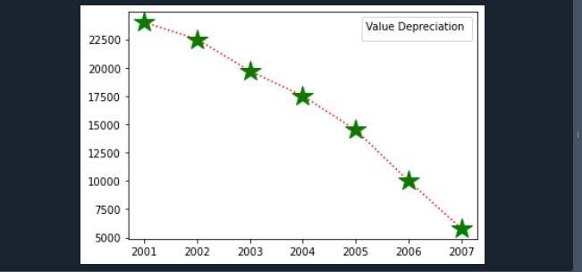

**2. Following table gives the daily sales of the following items in a shop**

|  |  |  |  |  |  |
| --- | --- | --- | --- | --- | --- |
| **Day** | **Mon** | **Tues** | **Wed** | **Thurs** | **Fri** |
| **Drinks** | **300** | **450** | **150** | **400** | **650** |
| **Food** | **400** | **500** | **350** | **300** | **500** |

**Use subplot function to draw the line graphs with grids(color as blue and line style dotted) for the**

**above information as 2 separate graphs in two rows**

**a) Properties for the Graph 1:**

**• X label- Days of week**

**• Y label-Sale of Drinks**

**• Title-Sales Data1 (right aligned)**

**• Line –dotted with cyan color**

**• Points- hexagon shape with color magenta and outline black**

**b) Properties for the Graph 2:**

**• X label- Days of Week**

**• Y label-Sale of Food**

**• Title-Sales Data2 ( center aligned)**

**• Line –dashed with yellow color**

**• Points- diamond shape with color green and outline red**

**Code**

**import matplotlib.pyplot as plt**

**import numpy as np**

**#plot 1:**

**x = np.array(['mon', 'tue', 'wed', 'thur','fri'])**

**y = np.array([300, 450, 150, 400,65])**

**plt.subplot(1, 2, 1)**

**plt.title("Sales Data1")**

**plt.xlabel("Days of week")**

**plt.ylabel("Sale of Drinks")**

**plt.plot(x,y,':c')**

**plt.plot(x,y,'Hm',mec = 'k')**

**plt.grid(color = 'blue', linestyle = 'dotted')**

**#plot 2:**

**c = np.array(['mon', 'tue', 'wed', 'thur','fri'])**

**v = np.array([400, 500, 350, 300,500])**

**plt.subplot(1, 2, 2)**

**plt.title("Sales Data2")**

**plt.xlabel("Days of Week")**

**plt.ylabel("Sale of Food")**

**plt.plot(c,v,'--y')**

**plt.plot(c,v,'Dg',mec = 'r')**

**plt.grid(color = 'blue', linestyle = 'dotted')**

**plt.show()**

**Output**

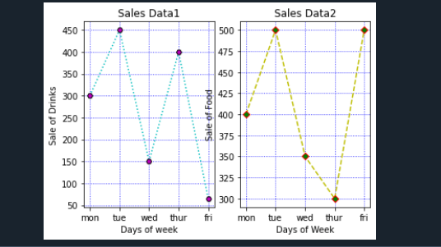

**3.Create scatter plot for the below data:(use Scatter function)**

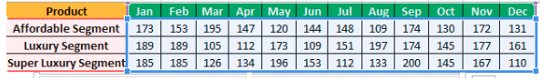

**Create scatter plot for each Segment with following properties within one graph**

**• X Label- Months of Year with font size 18**

**• Y-Label- Sales of Segments**

**• Title –Sales Data**

**• Color for Affordable segment- pink**

**• Color for Luxury Segment- Yellow**

**• Color for Super luxury segment-blue**

**Code**

**import matplotlib.pyplot as plt**

**import numpy as np**

**x = np.array(['jan','feb','mar','april','may','jun','july','aug','sep','oct','nov','dec'])**

**y1 = np.array([173,153,195,147,120,144,148,109,174,130,172,131])**

**y2 = np.array([189,189,105,112,173,109,151,197,174,195,177,161])**

**y3 = np.array([185,185,126,134,196,183,112,133,200,145,167,116])**

**font1={'size':18}**

**plt.scatter(x,y1,color='pink')**

**plt.scatter(x,y2,color='yellow')**

**plt.scatter(x,y3,color='blue')**

**plt.xlabel("Month of year",fontdict=font1)**

**plt.ylabel("Sales of segments")**

**plt.show()**

**Output**

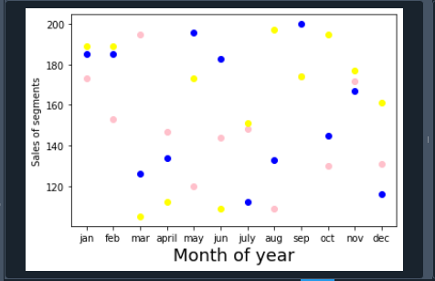

**4.Display the above data using multiline plot( 3 different lines in same graph)**

**• Display the description of the graph in upper right corner(use legend())**

**• Use different colors and line styles for 3 different lines.**

**Code**

**import matplotlib.pyplot as plt**

**import numpy as np**

**x = np.array(["Jan","Feb","Mar","Apr","May","Jun","Jul","Aug","Sep","Oct","Nov","Dec"])**

**y1 = np.array([173,153,195,147,120,144,148,109,174,130,172,131])**

**y2 = np.array([189,189,105,112,173,109,151,197,174,145,177,161])**

**y3 = np.array([185,185,126,134,196,153,112,133,200,145,167,110])**

**fig, ax = plt.subplots()**

**ax.plot(x, y1,label="affordable segment",ls=":")**

**ax.plot(x, y2,label="luxuary segment",ls="-.")**

**ax.plot(x,y3,label = "super segment")**

**ax.legend()**

**plt.show()**

**Output**

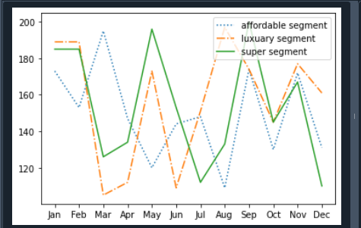

**5.100 students were asked what their primary mode of transport for getting to school was. The results of this survey are recorded in the table below. Construct a bar graph representing this information.**

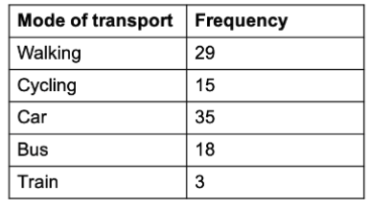

**Create a bar graph with**

* **• X axis -mode of Transport and Y axis ‘frequency’**
* **• Provide appropriate labels and title**
* **• Width .1, color green**

**Code**

**import matplotlib.pyplot as plt**

**import numpy as np**

**x = np.array(["walking", "cycling", "car", "bus","train"])**

**y = np.array([29,15,35,18,3])**

**plt.bar(x,y, color="#4CAF50",width=0.1)**

**plt.show()**

**Output**

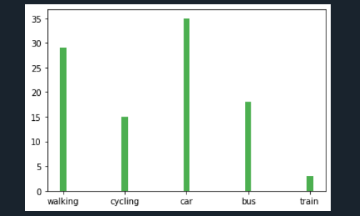

**6.We are provided with the height of 30 cherry trees.**

**The height of the trees (in inches): 61, 63, 64, 66, 68, 69, 71, 71.5, 72, 72.5, 73, 73.5, 74, 74.5, 76, 76.2,**

**76.5, 77, 77.5, 78, 78.5, 79, 79.2, 80, 81, 82, 83, 84, 85, 87.Create a histogram with a bin size of 5.**

**Code**

**import matplotlib.pyplot as plt**

**height = [61,63,64,66,68,69,**

**71,71.5,72,72.5,73,73.5,74,74.5,76,76.2,76.5,77,77.5,78,78.5,79,79.2,80,81,82,83,84,85,87**

**]**

**plt.hist(height, edgecolor="red", bins=5)**

**plt.show()**

**Output**

